.NET TECHNOLOGIES (01CE1523)
Lab Manual

Name: Thakrar Jeet Devendrkumar
Enrolment No: 92510103047
Class: 5EC1
Batch: B

INDEX

Lab | Program | CO | Date | Marks |  |  |  | Total | Signature
 |  |  |  | R1(4) | R2(2) | R3(2) | R4(2) | (10) | Signature
1. | Develop Student Admission Management Module using OOP Concepts (Class, Object, Constructor, Access Modifiers). | CO1
2. | Design Employee Payroll System using Inheritance, Interface & Polymorphism | CO1
3. | Develop Expense Tracking Module with Exception Handling | CO1
4. | Build Online Event Registration Portal using ASP.NET Controls & Validation | CO2
5. | Develop Academic Calendar & Leave Management System using Rich Controls, Session & Cookies | CO2
6. | Create Product Catalog Application using ASP.NET MVC Architecture. (Controllers, Models, Views, Routing) | CO3
7. | Develop Feedback Management Module using MVC Layout, Partial View & Validation. (HTML Helpers, Validation, Layouts) | CO3
8. | Develop Inventory Management Module using ADO.NET & CRUD Operations | CO4
9. | Create Placement Dashboard using Data Controls & Crystal Reports | CO4
10. | Build Student Management REST API using ASP.NET Core  (Middleware, API, Project Structure) | CO5
11. | Develop Smart Campus Service Portal – Feature Extension  (Integrate MVC + Database + API) | CO1,  CO2,  CO3,  CO4,  CO5

R1 | Practical Performance
R2 | Timely Submission
R3 | Neatness & Documentation
R4 | Uploaded on Git

Experiment 1
AIM: Develop Student Admission Management Module using OOP Concepts (Class, Object, Constructor, Access Modifiers).
Source: Program.cs
Code:
using System;
using System.Collections.Generic;
using System.Linq;
using System.Text;
using System.Threading.Tasks;

namespace Practical_1
{
internal class Program
{
static void Main(string[] args)
{
Student s1 = new Student();

s1.applicaiton();
s1.isscholar();
s1.showdata();

Console.ReadKey();
}
}
class Student
{
public int enrollment;
public string name;
public int age;
public string Dep;
private int fees;
private bool scholar;
private double finalfees;
public Student()
{
enrollment = 0;
name = "";
age = 0;
Dep = "Computer Eng";
fees = 0;
scholar = false;
finalfees = 0;
}

public void applicaiton()
{

Console.WriteLine("------------------------------------");
Console.WriteLine(" Wellcome to Student Module");
Console.WriteLine("------------------------------------");

Console.Write("Enter the enrollment no.: ");
enrollment = Convert.ToInt32(Console.ReadLine());

Console.Write("Enter the Name: ");
name = Console.ReadLine();

Console.Write("Enter the age: ");
age = Convert.ToInt32(Console.ReadLine());

//Console.Write("Enter the Department: ");
//Dep = Console.ReadLine();

Console.Write("Enter the Fees: ");
fees = Convert.ToInt32(Console.ReadLine());
}

public void isscholar()
{
if (fees <= 50000)
{
scholar = true;
}
else
{
scholar = false;
}
}

public void showdata()
{
finalfees = fees;
if (scholar)
{
finalfees = fees - (fees * 0.10);
}

Console.WriteLine("");

Console.WriteLine("------------------------------------");
Console.WriteLine(" Student Details");
Console.WriteLine("------------------------------------");

Console.WriteLine("Name of Student: " + name);
Console.WriteLine("enrollment : " + enrollment);
Console.WriteLine("age : " + age);

Console.WriteLine("fees : " + fees);
Console.WriteLine("Department : " + Dep);

Console.WriteLine("scholarship is applicable : " + scholar);
Console.WriteLine("Final Fees : " + finalfees);
Console.ReadKey();
}
}

}

Output:
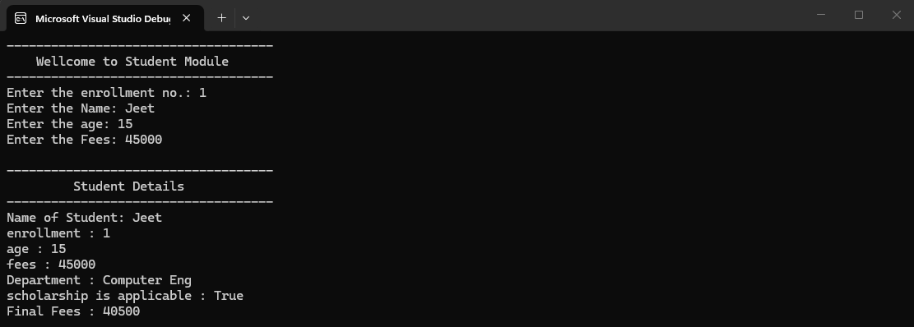
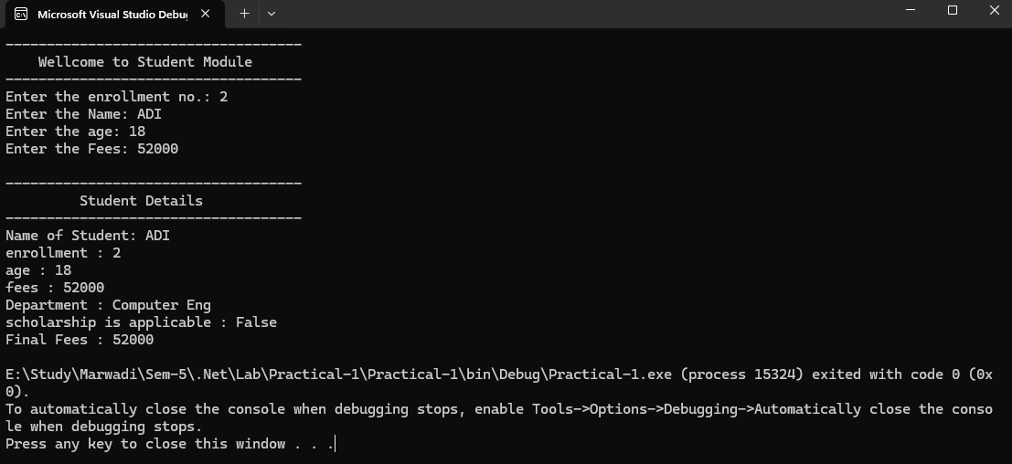

Github Url: https://github.com/jd-thakrar/Uni-DotNet-Work/tree/master/Practical-1

